PRAKTIKUM BASIS DATA

MODUL 4
04_Scripting_SQL_Pemrosesan

Oleh:

Haryanto Wifakul Azmi 103122400037

PROGRAM STUDI S1 REKAYASA PERANGKAT LUNAK
DIREKTORAT KAMPUS PURWOKERTO
UNIVERSITAS TELKOM
2026
Jurnal

- Soal 1
Query
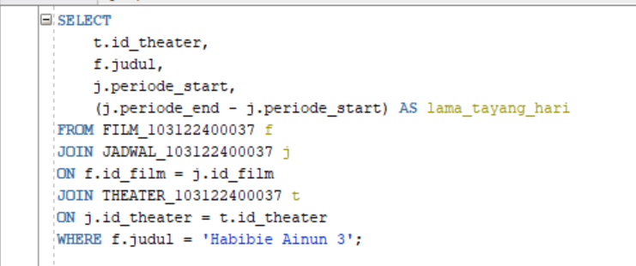
Output
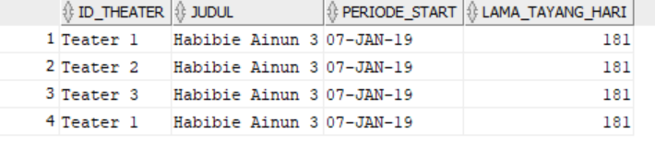
- Soal 2
Query
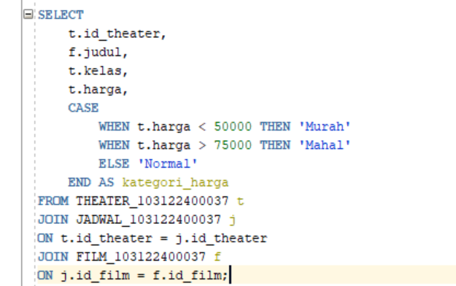
Output
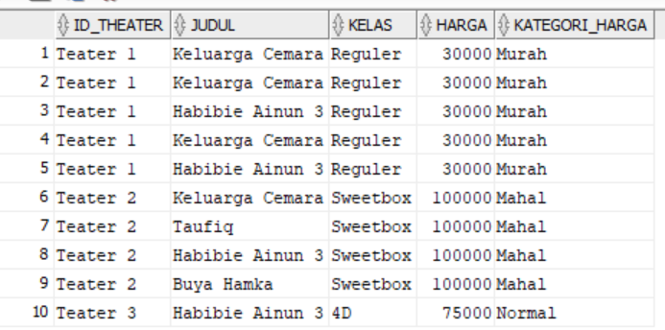
- Soal 3
Query
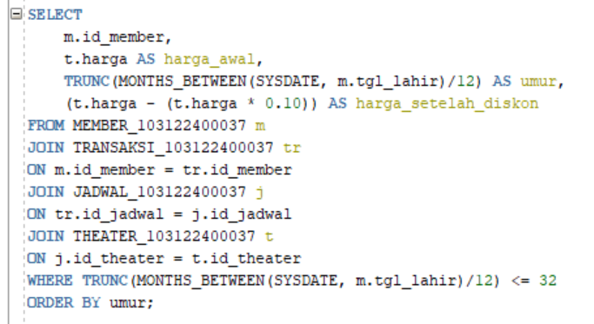
Output
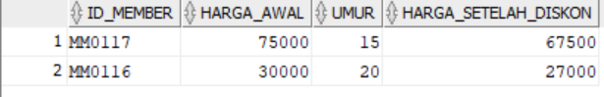
- Soal 4
Query
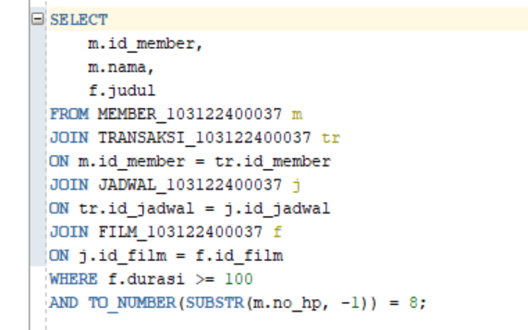
Output
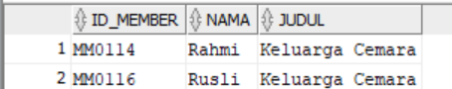
- Soal 5
Query
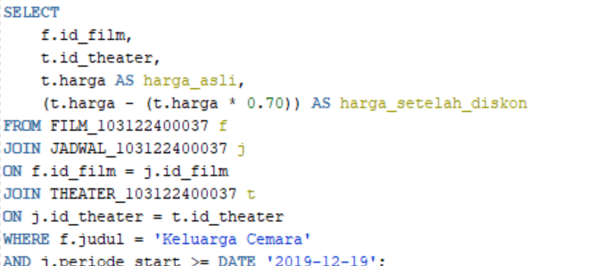
Output
